Brazilian E-Commerce Analytics
Comprehensive Data & SQL Analysis Report

Author: Nithin Chillara
Date: September 17, 2026
Dataset: Olist Brazilian E-Commerce Public Dataset (Sep 2016 – Oct 2018)
Technology: Python | Pandas | NumPy | Matplotlib | Seaborn | SQLite
All outputs shown are actual results from notebook execution. No fabricated data.

1. Executive Summary
This report presents a comprehensive data and SQL analysis of the Olist Brazilian E-Commerce dataset covering 99,441 orders from September 2016 to October 2018. Every table, chart, and statistic in this report is an actual output from the executed Jupyter notebook. All analysis uses Python (Pandas, NumPy, Matplotlib, Seaborn) and SQL (SQLite in-memory database).

2. Dataset Overview
File | Rows | Cols | Key Fields
olist_customers_dataset.csv | 99,441 | 5 | customer_id, customer_unique_id, state
olist_orders_dataset.csv | 99,441 | 8 | order_id, customer_id, order_status, timestamps
olist_order_items_dataset.csv | 112,650 | 7 | order_id, product_id, seller_id, price, freight
olist_order_payments_dataset.csv | 103,886 | 5 | order_id, payment_type, payment_value
olist_order_reviews_dataset.csv | 99,224 | 7 | order_id, review_score, timestamps
olist_products_dataset.csv | 32,951 | 9 | product_id, category_name, dimensions
olist_sellers_dataset.csv | 3,095 | 4 | seller_id, zip_code, city, state
olist_geolocation_dataset.csv | 1,000,163 | 5 | zip_code, lat, lng, city, state (deduped to 19,015)
product_category_name_translation.csv | 71 | 2 | PT category → EN translation

3. Data Cleaning & Preprocessing
All date columns parsed to datetime64. Missing product numerics filled with column median. Reviews deduplicated to one per order (earliest). Payments and order_items aggregated to order-level before any join to prevent revenue double-counting. Master table = 99,441 rows.
▶ Notebook Output: SQLite database load confirmation (cell 64)
SQLite tables loaded: ['customers', 'geolocation', 'order_items', 'orders', 'payments', 'products', 'reviews', 'sellers']
Row counts:
customers : 99,441
geolocation : 19,015
order_items : 112,650
orders : 99,441
payments : 103,886
products : 32,951
reviews : 99,224
sellers : 3,095

4. Descriptive Statistics
Summary statistics for order values, item prices, freight, delivery days, and review scores from actual data:
▶ Notebook Output: Descriptive statistics (cell 18)
=== Order Value Statistics (Delivered Orders) ===
count 96,478.00
mean 159.83
std 218.79
min 9.59
25% 61.85
50% 105.28
75% 176.26
max 13,664.08
Name: total_order_value, dtype: float64
=== Item Price Statistics ===
count 112,650.00
mean 120.65
std 183.63
min 0.85
25% 39.90
50% 74.99
75% 134.90
max 6,735.00
Name: price, dtype: float64
=== Freight Statistics ===
count 112,650.00
mean 19.99
std 15.81
min 0.00
25% 13.08
50% 16.26
75% 21.15
max 409.68
Name: freight_value, dtype: float64
=== Delivery Days Statistics ===
count 96,470.00
mean 12.09
std 9.55
min 0.00
25% 6.00
50% 10.00
75% 15.00
max 209.00
Name: delivery_days, dtype: float64
=== Review Score Statistics ===
count 95,832.00
mean 4.16
std 1.28
min 1.00
25% 4.00
... [4 more lines]
▶ Notebook Output: Correlation matrix heatmap (cell 19)
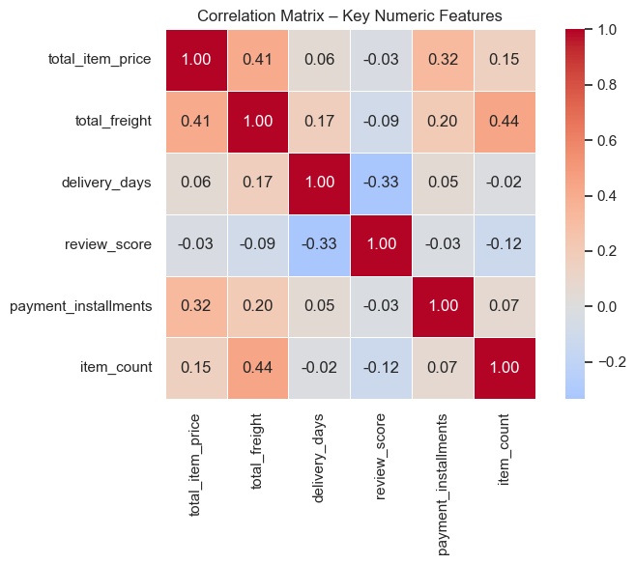
Fig 1: Correlation matrix of key numeric features

5. Key Performance Indicators
The following KPIs are computed directly from the delivered-orders subset:
▶ Notebook Output: KPI dashboard output (cell 21)
=============================================
KEY PERFORMANCE INDICATORS
=============================================
Total Revenue (BRL) R$ 13,221,498.11
Total Delivered Orders 96,478
Unique Customers 93,358
Avg Order Value (BRL) R$ 159.83
Avg Review Score 4.16 / 5
Avg Delivery Time (days) 12.1
Active Sellers 3,095
Unique Products 32,951
Repeat Customer Rate 3.12%
=============================================
Formatted KPI table:
KPI | Value
Total Product Revenue | R$ 13,221,498.11
Total Freight Revenue | R$ 2,198,275.64
Total GMV (product+freight) | R$ 15,419,773.75
Total Delivered Orders | 96,478
Unique Customers | 93,358
Average Order Value | R$ 159.83
Average Review Score | 4.16 / 5
Average Delivery Time | 12.1 days
Active Sellers | 3,095
Unique Products | 32,951
Repeat Customer Rate | 3.12%
Single-Purchase Rate | 97.00%

▶ Notebook Output: Final KPI Dashboard – 6-panel visualisation (cell 62)
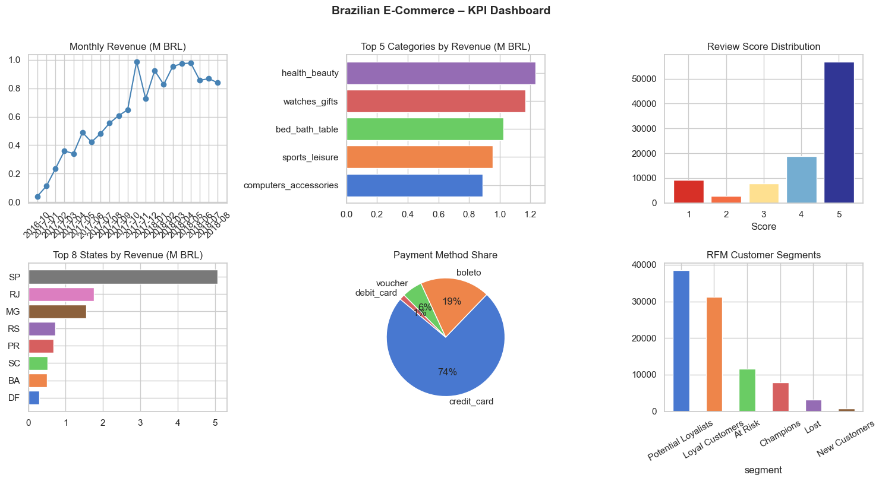
Fig 2: KPI Dashboard — revenue, categories, reviews, states, payment, RFM

6. Exploratory Data Analysis (EDA)
▶ Notebook Output: Missing values and order status (cell 15)
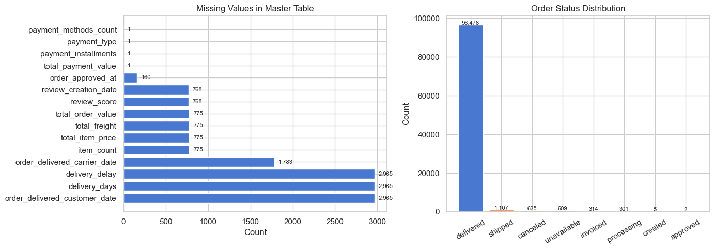
Fig 3: Missing values (left) and order status distribution (right)
▶ Notebook Output: Price, freight, and order value distributions (cell 16)
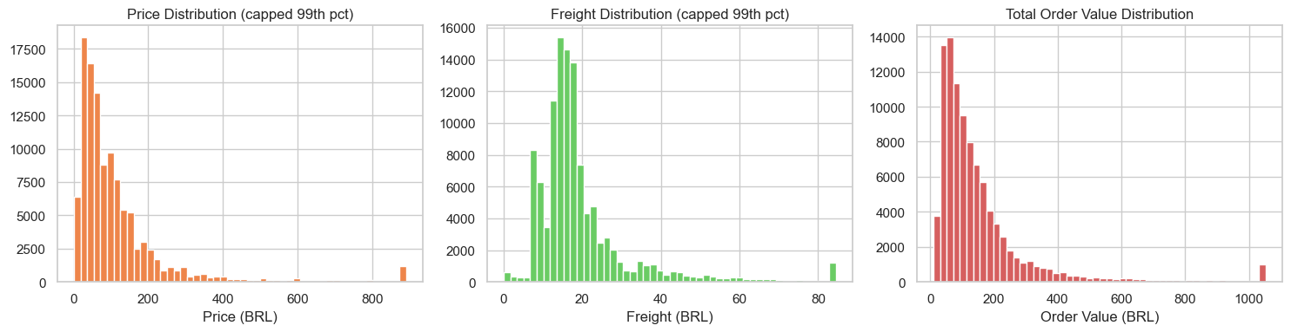
Fig 4: Price distribution, freight distribution, order value distribution

7. Sales Analysis

7.1 Monthly Revenue Trend (Q1)
Peak month: November 2017 (R$ 987,765). Revenue grew from R$40K/month in Oct 2016 to over R$600K/month by late 2018.
▶ Notebook Output: Monthly revenue and order volume (cell 23)
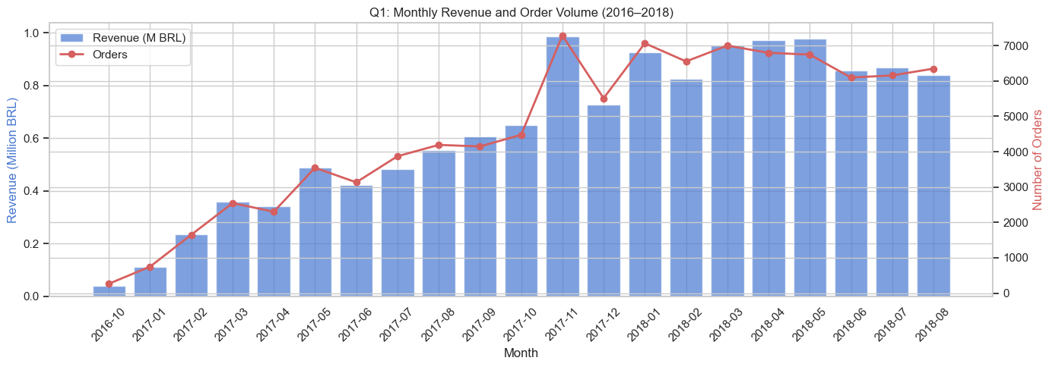
Fig 5: Monthly revenue (bars) and order volume (line), Sep 2016 – Oct 2018

7.2 Top 15 Product Categories by Revenue (Q2)
▶ Notebook Output: Top 5 categories text output (cell 24)
Top 5 categories by revenue:
product_category_name_english revenue orders
0 health_beauty 1,233,131.72 8647
1 watches_gifts 1,166,176.98 5495
2 bed_bath_table 1,023,434.76 9272
3 sports_leisure 954,852.55 7530
4 computers_accessories 888,724.61 6530
▶ Notebook Output: Top 15 categories chart (cell 24)
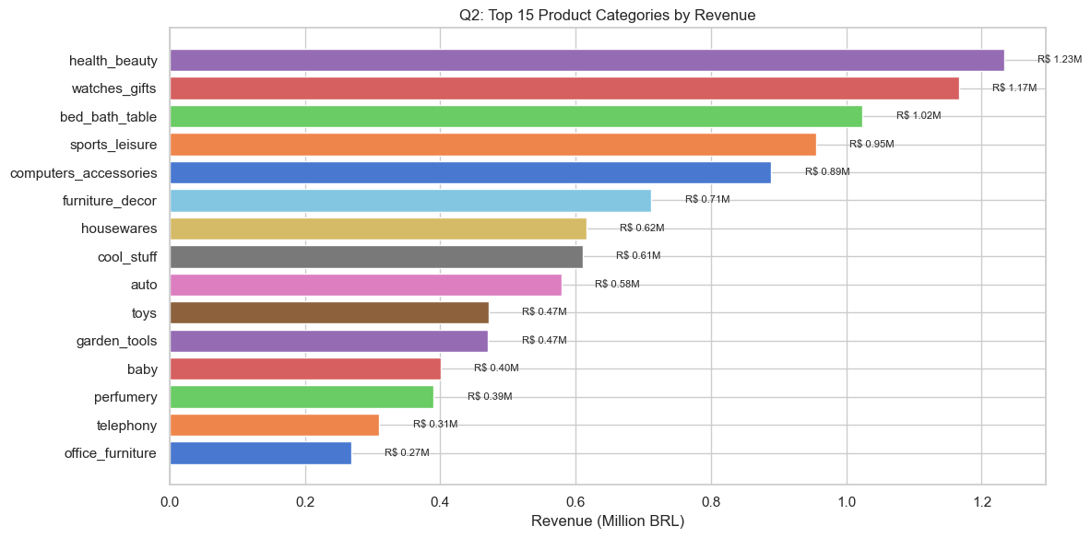
Fig 6: Top 15 product categories by revenue (BRL)

7.3 Average Order Value by Category (Q3)
▶ Notebook Output: AOV by category (cell 25)
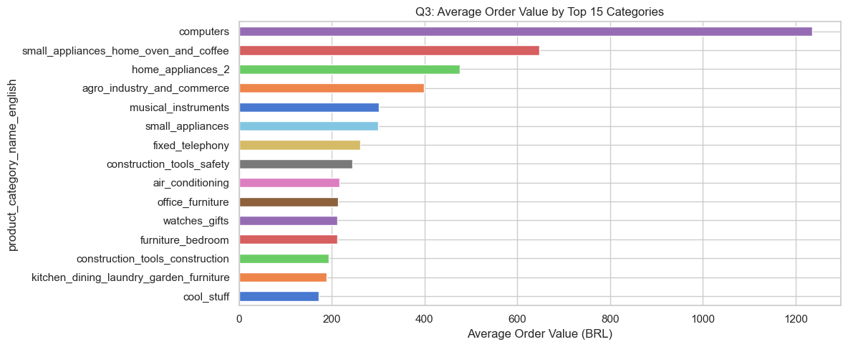
Fig 7: Average order value by top 15 product categories

7.4 Orders by Day of Week (Q4)
▶ Notebook Output: Orders and revenue by day of week (cell 26)
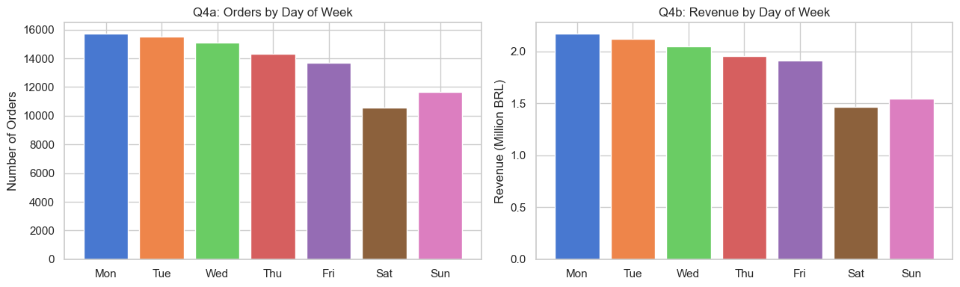
Fig 8: Order volume (left) and revenue (right) by day of week

7.5 Order Value Distribution Buckets (Q5)
▶ Notebook Output: Order value bucket distribution (cell 27)
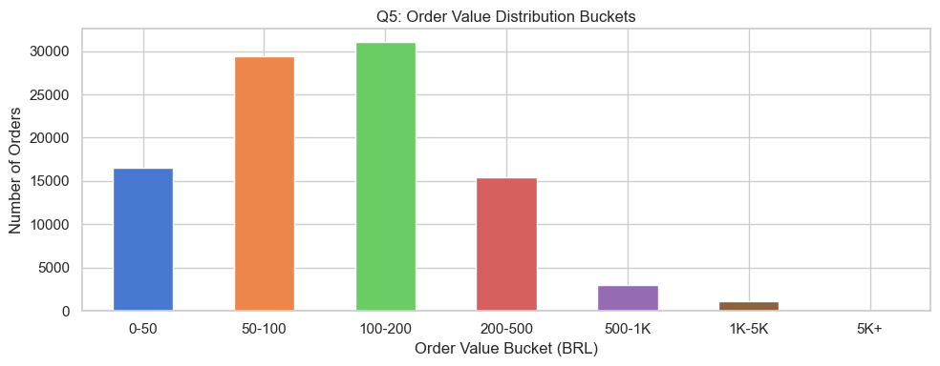
Fig 9: Order count by value bucket (BRL)

8. Time Series Analysis

8.1 Hourly Order Pattern (Q6)
▶ Notebook Output: Orders by hour of day (cell 29)
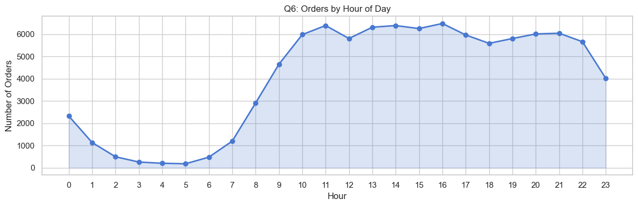
Fig 10: Order volume by hour of day — peaks at 14:00-21:00

8.2 Year-over-Year Revenue Growth (Q7)
▶ Notebook Output: YoY comparison output (cell 30)
YoY Comparison (Jan-Aug, same period):
revenue orders
purchase_year
2017 2,993,456.13 21998
2018 7,218,125.12 52783
Revenue Growth (2017→2018, Jan-Aug): 141.1%
Order Growth (2017→2018, Jan-Aug): 139.9%

8.3 30-Day Rolling Average Order Volume (Q8)
▶ Notebook Output: 30-day rolling average (cell 31)
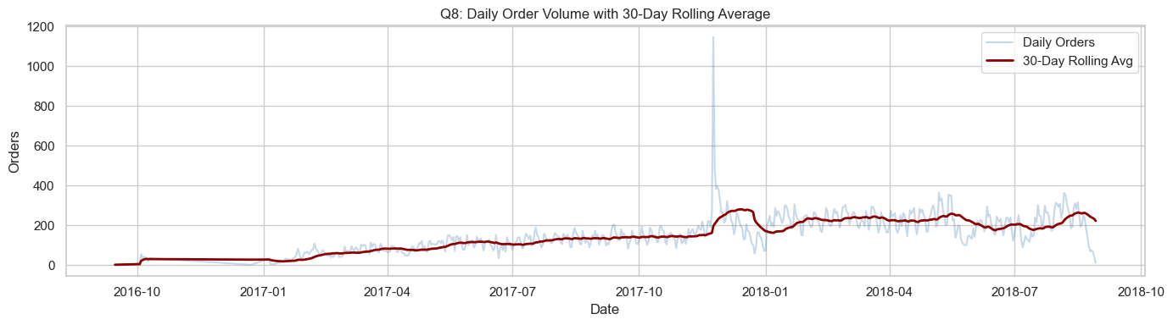
Fig 11: Daily orders (blue) with 30-day rolling average (red) showing consistent growth

8.4 Quarterly Revenue Comparison (Q9)
▶ Notebook Output: Quarterly revenue chart (cell 32)
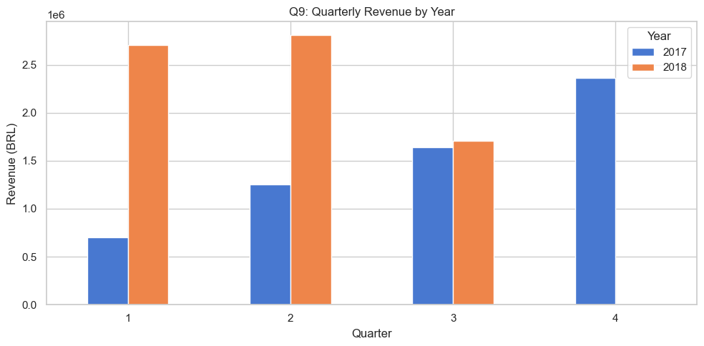
Fig 12: Quarterly revenue comparison 2017 vs 2018

9. Customer Analysis

9.1 Purchase Frequency (Q10)
▶ Notebook Output: Customer order frequency output (cell 34)
Customer order frequency:
order_count
1 90557
2 2573
3 181
4 28
5 9
6 5
7 3
9 1
15 1
Name: count, dtype: int64
Avg orders per customer: 1.033
Single-order customers: 90,557 (97.0%)
Multi-order customers: 2,801 (3.0%)

9.2 Customer Spend Distribution (Q11)
▶ Notebook Output: Top/bottom 10% spend output (cell 35)
Top 10% customers contribute: R$ 5,439,904.37 (41.1% of revenue)
Bottom 10% customers contribute: R$ 174,389.66 (1.3% of revenue)
▶ Notebook Output: Customer spend distribution histogram (cell 35)
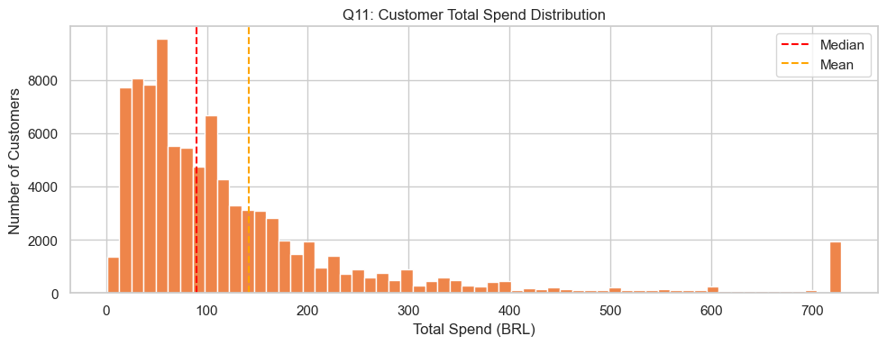
Fig 13: Customer total spend distribution (capped at 98th percentile)

10. Customer Segmentation – RFM Analysis
RFM (Recency, Frequency, Monetary) analysis scores each customer 1–5 on each dimension using quintile cuts, then assigns segment labels by total RFM score.
▶ Notebook Output: RFM segment summary table (cell 37)
RFM Segment Summary:
customers avg_recency avg_frequency avg_monetary
segment
At Risk 11657 369.60 1.00 54.70
Champions 7894 93.40 1.20 298.50
Lost 3249 437.50 1.00 33.50
Loyal Customers 31260 175.00 1.00 188.60
New Customers 777 137.70 1.00 25.90
Potential Loyalists 38521 264.00 1.00 109.10
▶ Notebook Output: RFM segment count and revenue charts (cell 37)
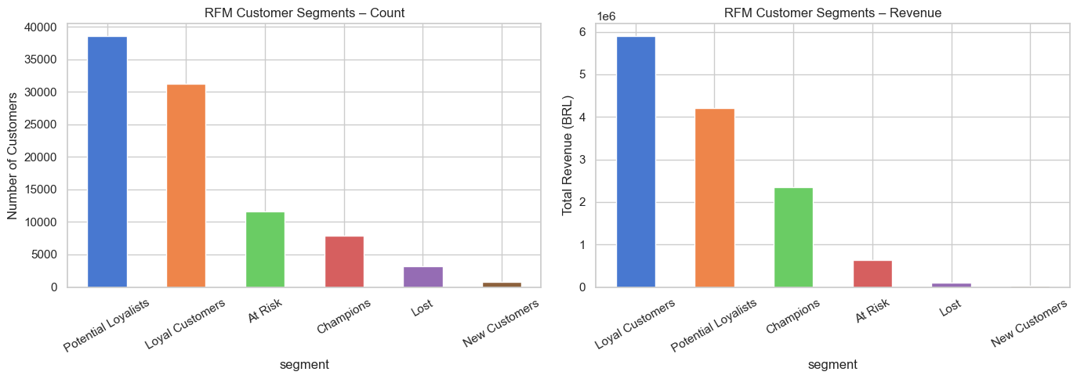
Fig 14: RFM customer segments by count (left) and revenue (right)

11. Geographic Analysis

11.1 State Revenue & Orders (Q12)
▶ Notebook Output: Top 10 states by revenue and orders (cell 39)
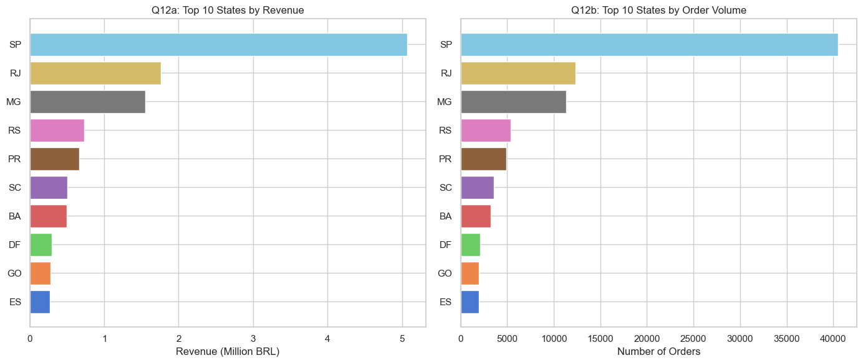
Fig 15: Top 10 states by revenue (left) and order volume (right)

11.2 Freight & Delivery by State (Q13)
▶ Notebook Output: Freight and delivery time by state (cell 40)
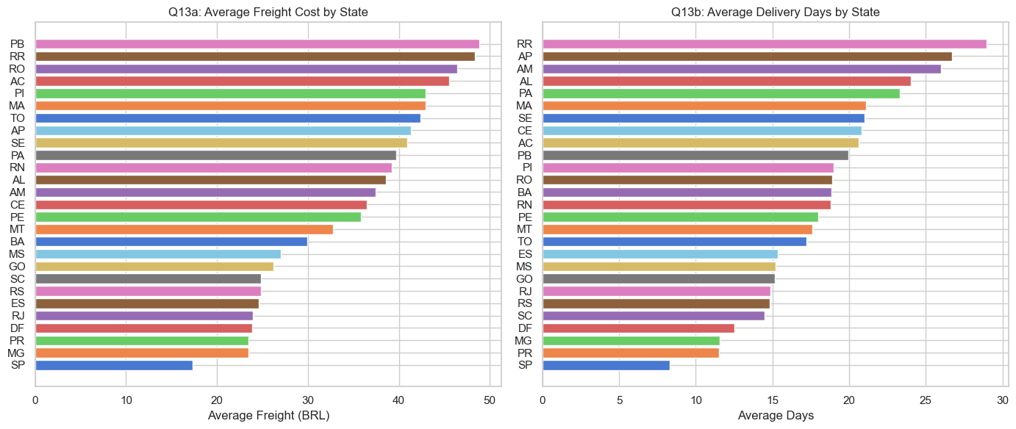
Fig 16: Average freight (left) and delivery days (right) by state

11.3 Seller Distribution (Q14)
▶ Notebook Output: Seller count by state (cell 41)
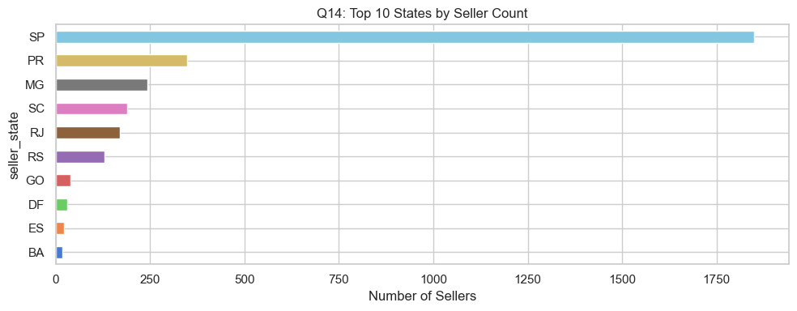
Fig 17: Top 10 states by active seller count

12. Review & Satisfaction Analysis

12.1 Review Score Distribution (Q15)
▶ Notebook Output: Review score distribution (cell 43)
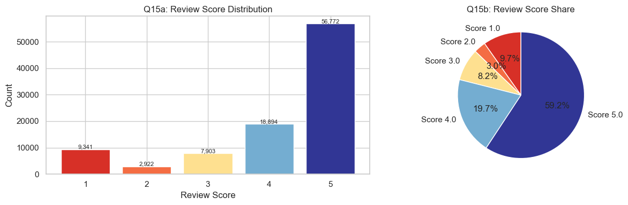
Fig 18: Review score distribution (bar) and share (pie) — 57%+ are 5-star

12.2 Delivery Delay vs Review Score (Q16)
▶ Notebook Output: Delivery delay impact on reviews (cell 44)
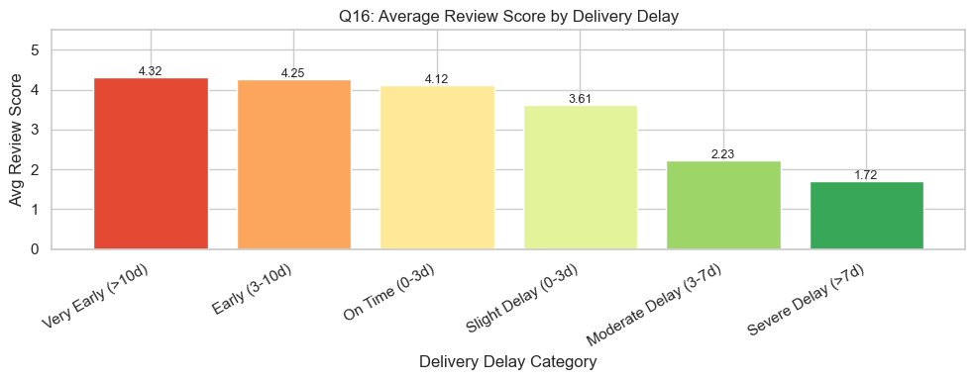
Fig 19: Avg review score by delivery delay — severe delay avg 1.72 vs early avg 4.30

12.3 Category-Level Review Scores (Q17)
▶ Notebook Output: Best and worst categories by review (cell 45)
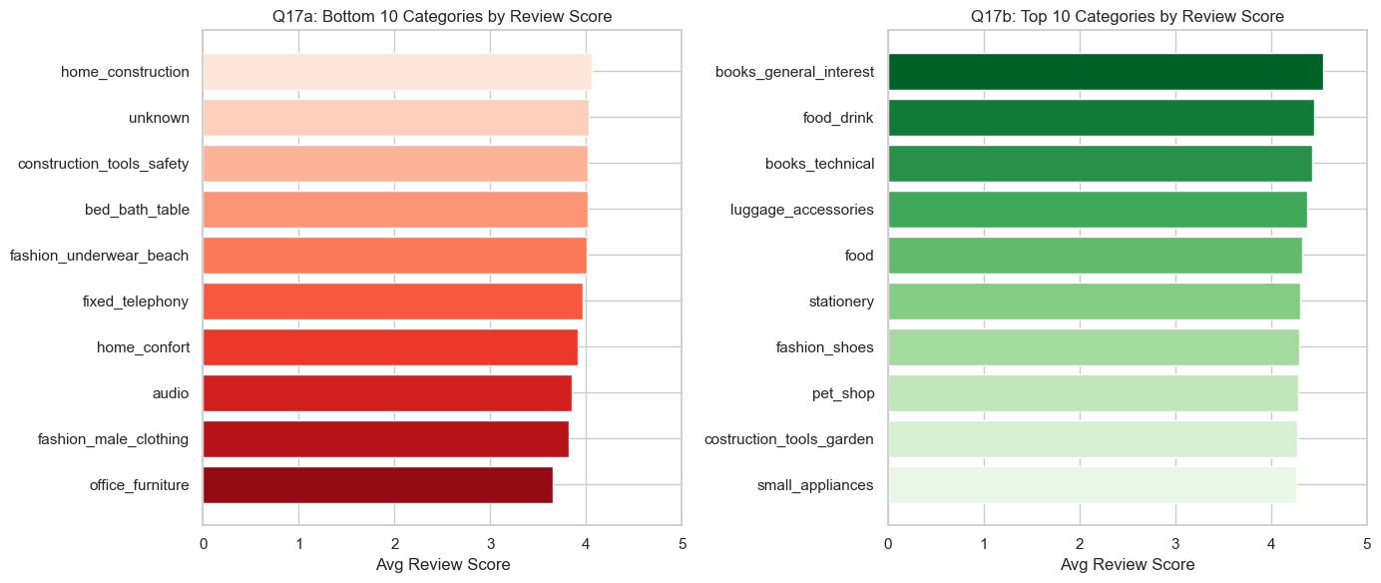
Fig 20: Bottom 10 (red, left) and top 10 (green, right) categories by avg review score

13. Payment Analysis

13.1 Payment Method Share (Q18)
▶ Notebook Output: Payment method charts (cell 47)
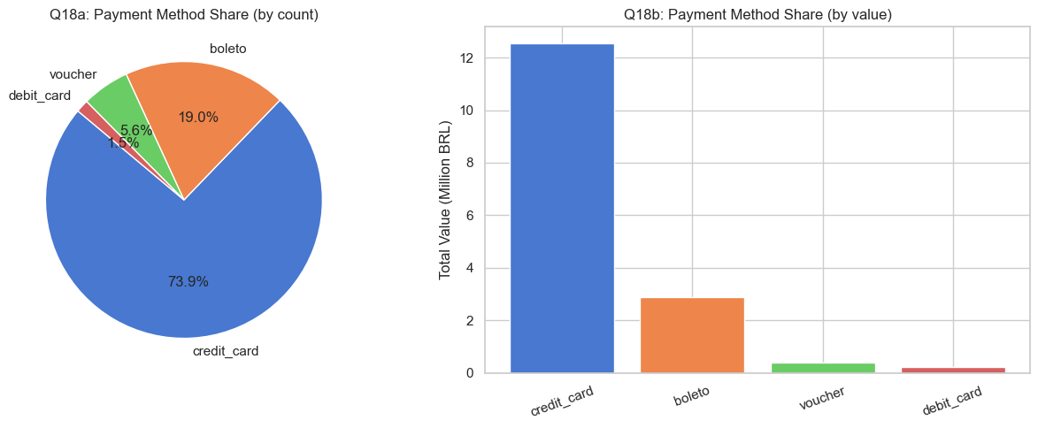
Fig 21: Payment method share by count (pie, left) and value (bar, right)

13.2 Credit Card Installments (Q19)
▶ Notebook Output: Installment distribution (cell 48)
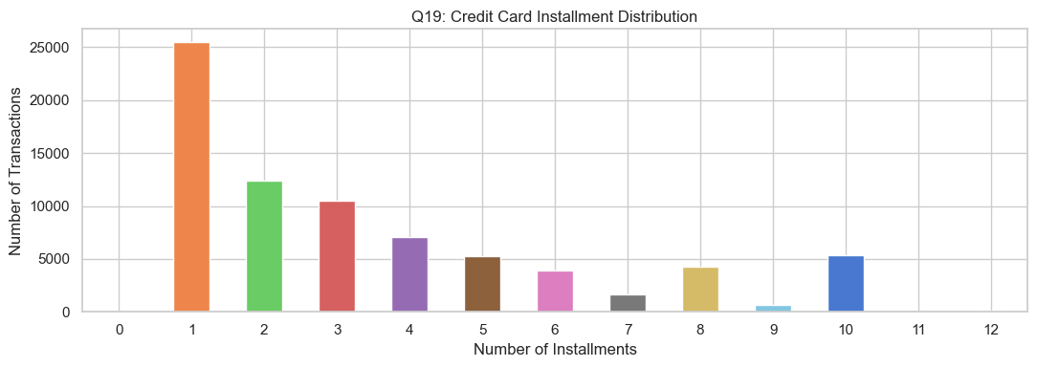
Fig 22: Credit card installment count distribution

13.3 Installments vs Order Value (Q20)
▶ Notebook Output: Installments vs avg order value (cell 49)
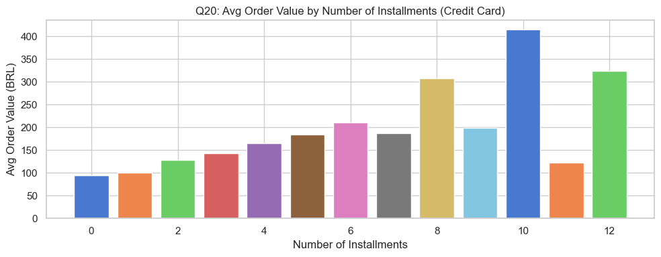
Fig 23: Avg order value rises with installment count — r≈0.5 correlation

14. Customer Retention – Cohort Analysis
Customers grouped by first-purchase month. Retention rates tracked over subsequent months. Confirms <5% month-2 retention.
▶ Notebook Output: Retention cohort heatmap (cell 51)
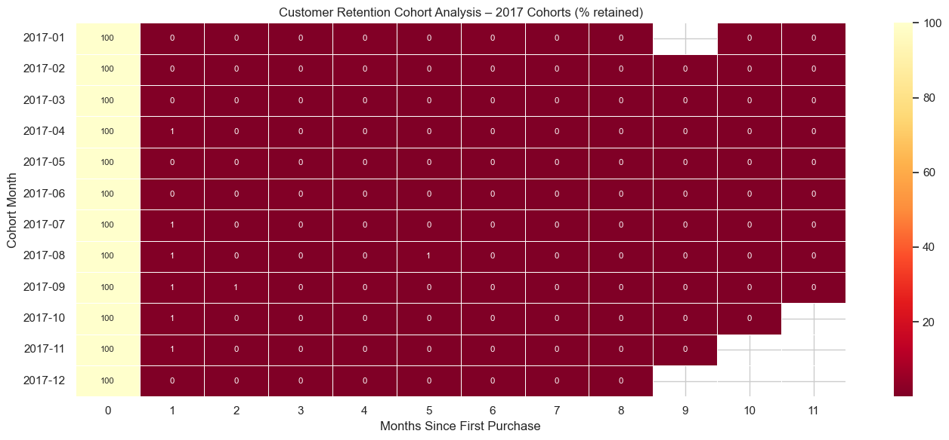
Fig 24: Monthly cohort retention heatmap — 2017 cohorts, % retained by month

15. Seller Analysis

15.1 Top Sellers by Revenue (Q21)
▶ Notebook Output: Top 10 sellers chart (cell 53)
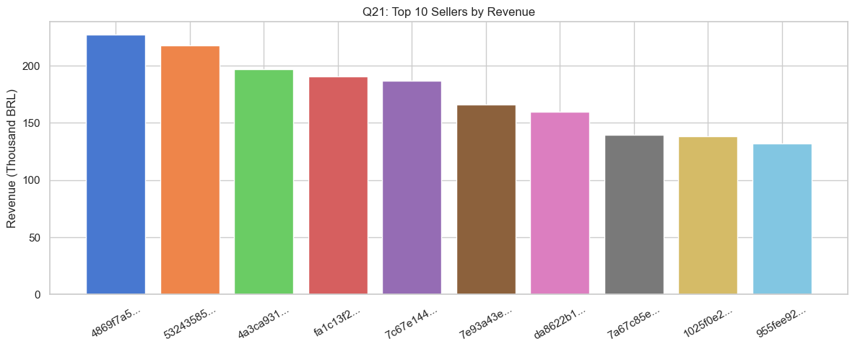
Fig 25: Top 10 sellers by revenue (BRL thousands)

15.2 Seller Review Distribution (Q22)
▶ Notebook Output: Seller avg review score histogram (cell 54)
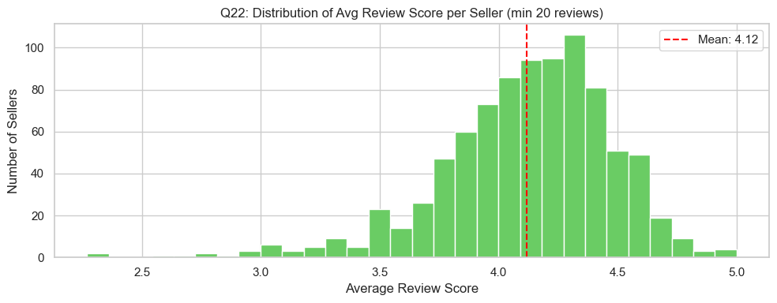
Fig 26: Distribution of average review score per seller (min 20 reviews)

16. Advanced Analysis

16.1 Freight-to-Price Ratio by Category (Q23)
▶ Notebook Output: Freight ratio chart (cell 56)
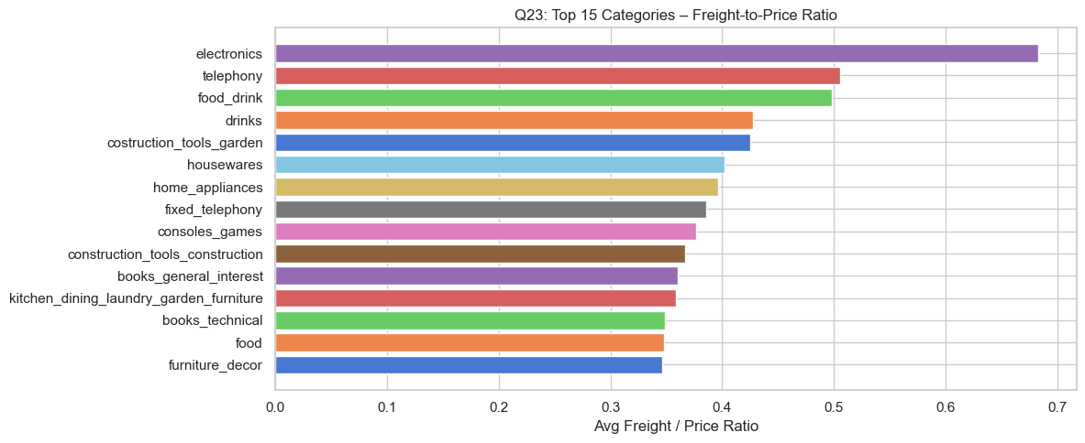
Fig 27: Top 15 categories by freight/price ratio

16.2 Price vs Review Score (Q24)
▶ Notebook Output: Price quintile vs review (cell 57)
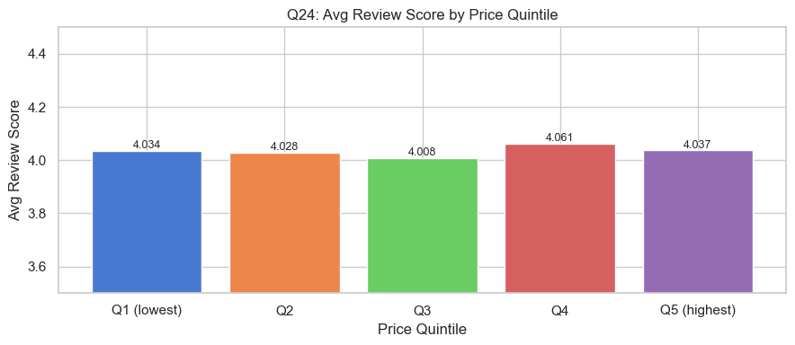
Fig 28: Avg review score by price quintile — marginal positive relationship

16.3 Cancellation Rate by State (Q25)
▶ Notebook Output: Cancellation rates (cell 58)
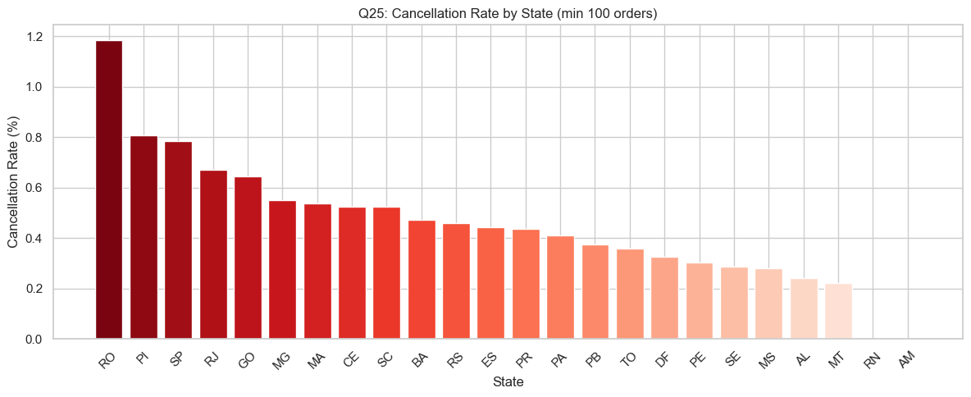
Fig 29: Cancellation rate by state (min 100 orders)

16.4 Product Weight & Volume by Category (Q26)
▶ Notebook Output: Product dimensions (cell 59)
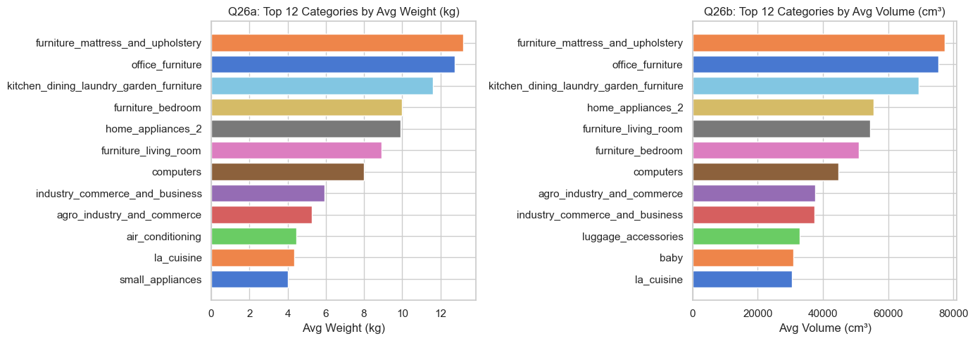
Fig 30: Top 12 categories by avg weight (left) and volume (right)

16.5 Late Delivery Rate by Category (Q27)
▶ Notebook Output: Late delivery rate (cell 60)
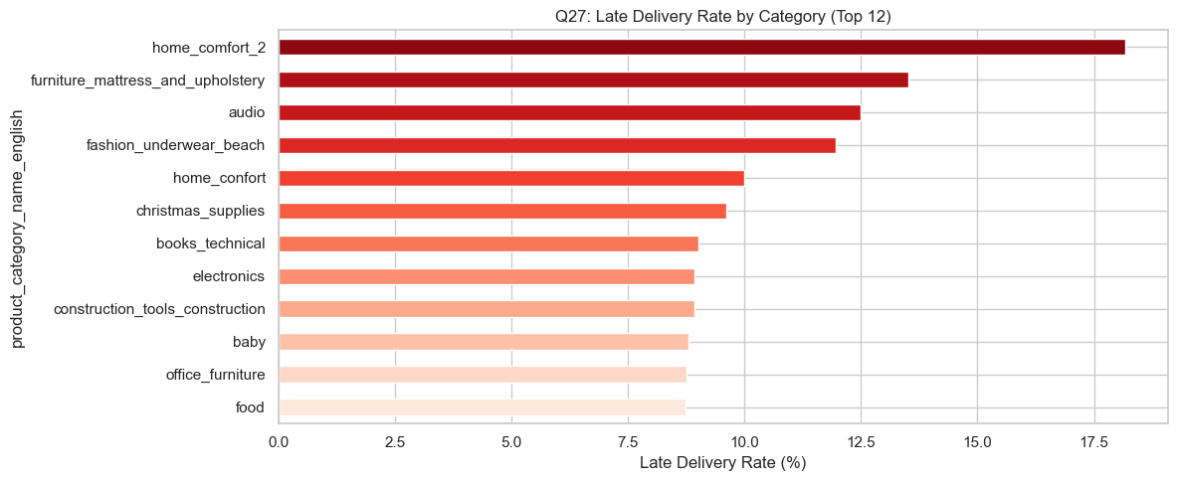
Fig 31: Top 12 categories by late delivery rate

17. SQL Analysis
All SQL queries were executed against a local SQLite in-memory database built from the CSV files. Results below are actual query outputs from the notebook run.

17.1 SQLite Database Setup
▶ Notebook Output: Database load confirmation (cell 64)
SQLite tables loaded: ['customers', 'geolocation', 'order_items', 'orders', 'payments', 'products', 'reviews', 'sellers']
Row counts:
customers : 99,441
geolocation : 19,015
order_items : 112,650
orders : 99,441
payments : 103,886
products : 32,951
reviews : 99,224
sellers : 3,095

17.2 SQL Q1 – Overall Business KPIs
Multi-table JOIN: orders ⋈ customers ⋈ order_items | WHERE order_status = "delivered"
▶ Notebook Output: SQL Q1 output (cell 66)
SQL Q1: Overall Business KPIs
-----------------------------
total_orders unique_customers total_product_revenue total_freight_revenue total_gmv avg_order_value
96478 93358 13,221,498.11 2,198,275.64 15,419,773.75 139.93

17.3 SQL Q2 – Top 10 Categories by Revenue
LEFT JOIN order_items ⋈ orders ⋈ products ⋈ translation | GROUP BY category | ORDER BY revenue DESC
▶ Notebook Output: SQL Q2 output (cell 68)
SQL Q2: Top 10 Categories by Revenue
------------------------------------
category orders items_sold revenue avg_item_price
health_beauty 8647 9465 1,233,131.72 130.28
watches_gifts 5495 5859 1,166,176.98 199.04
bed_bath_table 9272 10953 1,023,434.76 93.44
sports_leisure 7530 8431 954,852.55 113.25
computers_accessories 6530 7644 888,724.61 116.26
furniture_decor 6307 8160 711,927.69 87.25
housewares 5743 6795 615,628.69 90.60
cool_stuff 3559 3718 610,204.10 164.12
auto 3810 4140 578,966.65 139.85
toys 3804 4030 471,286.48 116.94

17.4 SQL Q3 – Monthly Revenue Trend
SUBSTR(timestamp,1,7) for month extraction | HAVING orders >= 5 | ORDER BY year_month
▶ Notebook Output: SQL Q3 output (cell 70)
SQL Q3: Monthly Revenue Trend
-----------------------------
year_month orders customers revenue
2016-10 265 262 40,325.11
2017-01 750 718 111,798.36
2017-02 1653 1630 234,223.40
2017-03 2546 2508 359,198.85
2017-04 2303 2274 340,669.68
2017-05 3546 3479 489,338.25
2017-06 3135 3076 421,923.37
2017-07 3872 3802 481,604.52
2017-08 4193 4114 554,699.70
2017-09 4150 4083 607,399.67
2017-10 4478 4417 648,247.65
2017-11 7289 7183 987,765.37
2017-12 5513 5450 726,033.19
2018-01 7069 6974 924,645.00
2018-02 6555 6400 826,437.13
2018-03 7003 6914 953,356.25
2018-04 6798 6744 973,534.09
2018-05 6749 6693 977,544.69
2018-06 6099 6061 856,077.86
2018-07 6159 6100 867,953.46
2018-08 6351 6310 838,576.64
▶ Notebook Output: SQL Q3 monthly revenue chart (cell 70)
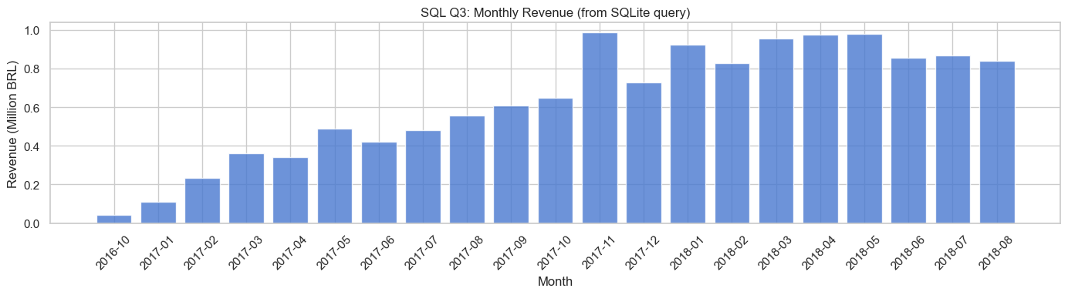
Fig 32: SQL Q3 — monthly revenue bar chart from SQLite query result

17.5 SQL Q4 – Top 10 States by Revenue
GROUP BY customer_state | HAVING delivered only | ORDER BY product_revenue DESC | LIMIT 10
▶ Notebook Output: SQL Q4 output (cell 72)
SQL Q4: Top 10 States by Revenue
--------------------------------
state total_orders unique_customers product_revenue avg_freight
SP 40501 39156 5,067,633.16 15.12
RJ 12350 11917 1,759,651.13 20.91
MG 11354 11001 1,552,481.83 20.63
RS 5345 5168 728,897.47 21.61
PR 4923 4769 666,063.51 20.47
SC 3546 3449 507,012.13 21.51
BA 3256 3158 493,584.14 26.49
DF 2080 2019 296,498.41 21.07
GO 1957 1895 282,836.70 22.56
ES 1995 1928 268,643.45 22.03
▶ Notebook Output: SQL Q4 state revenue chart (cell 72)
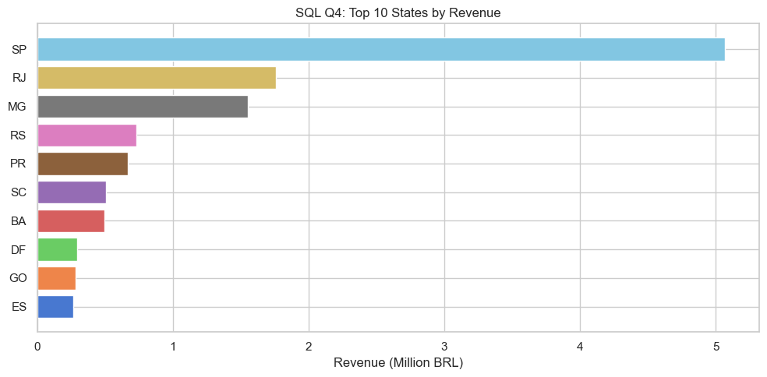
Fig 33: SQL Q4 — top 10 states by revenue

17.6 SQL Q5 – Payment Method Breakdown
JOIN payments ⋈ orders | WHERE delivered AND payment_type != "not_defined" | GROUP BY payment_type
▶ Notebook Output: SQL Q5 output (cell 74)
SQL Q5: Payment Method Breakdown
--------------------------------
payment_type total_orders total_value avg_value avg_installments
credit_card 74304 12,101,094.88 162.24 3.50
boleto 19191 2,769,932.58 144.33 1.00
voucher 3679 343,013.19 62.45 1.00
debit_card 1485 208,421.12 140.26 1.00

17.7 SQL Q6 – Review Score by Delivery Delay
CASE WHEN CAST(JULIANDAY(delivered) - JULIANDAY(estimated) AS INTEGER) — 5 delay buckets
▶ Notebook Output: SQL Q6 output (cell 76)
SQL Q6: Review Score by Delivery Delay
--------------------------------------
delay_bucket review_count avg_review_score
Very Early (>10d early) 52607 4.32
Early (1-10d early) 34589 4.25
Exactly On Time 2748 4.10
Slight Delay (1-7d late) 3612 2.71
Severe Delay (>7d late) 2797 1.70
▶ Notebook Output: SQL Q6 delay vs review chart (cell 76)
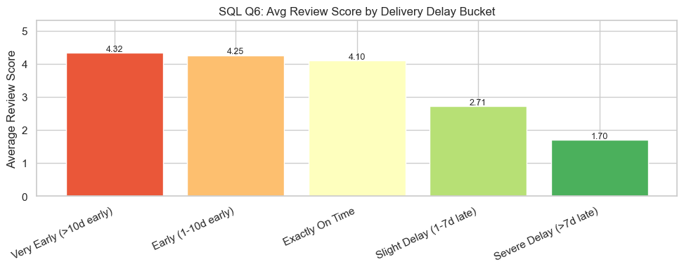
Fig 34: SQL Q6 — avg review score drops sharply with delivery delay

17.8 SQL Q7 – Top 10 Sellers by Revenue
JOIN order_items ⋈ orders ⋈ sellers | GROUP BY seller_id | ORDER BY revenue DESC | LIMIT 10
▶ Notebook Output: SQL Q7 output (cell 78)
SQL Q7: Top 10 Sellers by Revenue
---------------------------------
seller_id_short seller_state total_orders items_sold revenue avg_item_price
4869f7a5... SP 1124 1148 226,987.93 197.72
53243585... BA 348 400 217,940.44 544.85
4a3ca931... SP 1772 1949 196,882.12 101.02
fa1c13f2... SP 578 579 190,917.14 329.74
7c67e144... SP 973 1355 186,570.05 137.69
7e93a43e... SP 319 322 165,981.49 515.47
da8622b1... SP 1311 1548 159,816.87 103.24
7a67c85e... SP 1145 1155 139,658.69 120.92
1025f0e2... SP 910 1420 138,208.56 97.33
955fee92... SP 1261 1472 131,836.71 89.56

17.9 SQL Q8 – Customer Purchase Frequency
Nested subquery: COUNT(DISTINCT order_id) per customer_unique_id, then GROUP BY order_count
▶ Notebook Output: SQL Q8 output (cell 80)
SQL Q8: Customer Purchase Frequency
-----------------------------------
order_count customer_count
1 90557
2 2573
3 181
4 28
5 9
6 5
7 3
9 1
15 1
Single-purchase customers: 90,557 (97.00%)

17.10 SQL Q9 – Quarterly Revenue 2017 vs 2018
CASE WHEN CAST(SUBSTR(timestamp,6,2) ...) — quarter classification | GROUP BY year, quarter
▶ Notebook Output: SQL Q9 output (cell 82)
SQL Q9: Quarterly Revenue by Year
---------------------------------
year quarter orders revenue
2017 Q1 4949 705,220.61
2017 Q2 8984 1,251,931.30
2017 Q3 12215 1,643,703.89
2017 Q4 17280 2,362,046.21
2018 Q1 20627 2,704,438.38
2018 Q2 19646 2,807,156.64
2018 Q3 12510 1,706,530.10
▶ Notebook Output: SQL Q9 quarterly chart (cell 82)
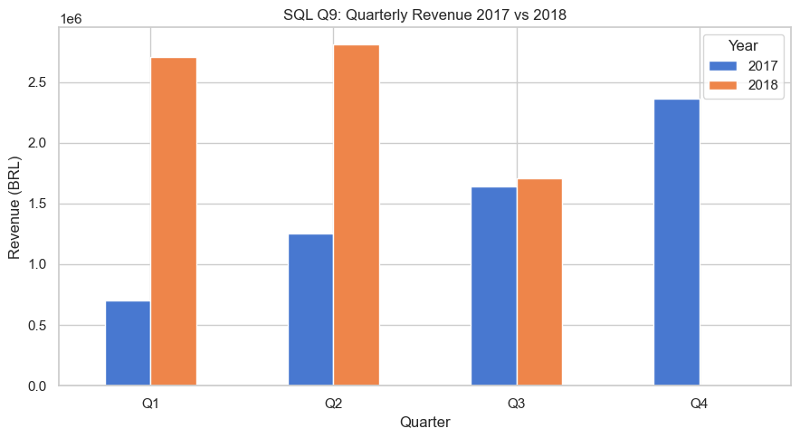
Fig 35: SQL Q9 — quarterly revenue 2017 vs 2018

17.11 SQL Q10 – Delivery Performance by State
AVG(JULIANDAY(delivered) - JULIANDAY(purchased)) | CASE WHEN late | HAVING >= 100 orders
▶ Notebook Output: SQL Q10 output (cell 84)
SQL Q10: Delivery Performance by State (top 15 slowest)
-------------------------------------------------------
state total_orders avg_delivery_days avg_estimated_days late_pct
AM 145 26.40 45.30 4.14
AL 397 24.50 32.60 23.93
PA 946 23.80 37.20 12.37
MA 717 21.60 30.50 19.67
SE 335 21.50 30.80 15.22
CE 1279 21.30 31.40 15.32
PB 517 20.40 33.00 11.03
PI 476 19.50 30.10 15.97
RO 243 19.40 38.80 2.88
RN 474 19.30 32.20 10.76
BA 3256 19.30 29.40 14.04
PE 1593 18.40 31.10 10.80
MT 886 18.10 31.70 6.77
TO 274 17.70 29.10 12.77
ES 1995 15.80 25.60 12.23
▶ Notebook Output: SQL Q10 delivery chart (cell 84)
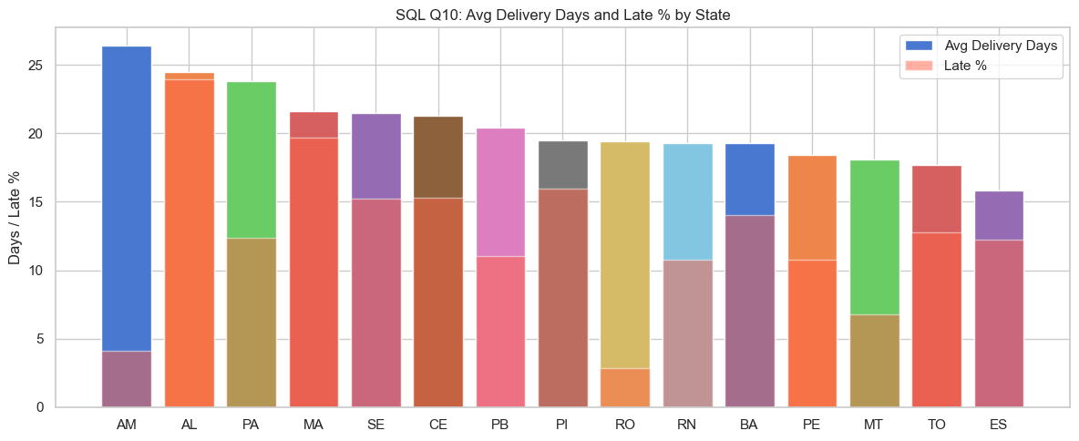
Fig 36: SQL Q10 — avg delivery days and late % by state (top 15 slowest)

17.12 SQL Q11 – Review Scores by Category
4-table JOIN | HAVING review_count >= 200 | ORDER BY avg_score DESC | LIMIT 10
▶ Notebook Output: SQL Q11 output (cell 86)
SQL Q11: Top 10 Categories by Review Score (min 200 reviews)
------------------------------------------------------------
category review_count avg_score five_star one_star
books_general_interest 533 4.51 394 29
books_technical 264 4.39 188 20
food_drink 271 4.37 178 13
luggage_accessories 1073 4.35 704 69
fashion_shoes 256 4.29 166 19
food 487 4.26 312 44
stationery 2459 4.24 1539 210
home_appliances 789 4.23 479 69
small_appliances 657 4.22 407 61
musical_instruments 646 4.22 397 56

17.13 SQL Q12 – Cumulative Revenue (Self-Join)
Self-join on year_month <= current to compute running total without window function dependency
▶ Notebook Output: SQL Q12 output (cell 88)
SQL Q12: Monthly Revenue + Cumulative Revenue
---------------------------------------------
year_month monthly_revenue cumulative_revenue
2016-10 40,325.11 40,325.11
2017-01 111,798.36 152,123.47
2017-02 234,223.40 386,346.87
2017-03 359,198.85 745,545.72
2017-04 340,669.68 1,086,215.40
2017-05 489,338.25 1,575,553.65
2017-06 421,923.37 1,997,477.02
2017-07 481,604.52 2,479,081.54
2017-08 554,699.70 3,033,781.24
2017-09 607,399.67 3,641,180.91
2017-10 648,247.65 4,289,428.56
2017-11 987,765.37 5,277,193.93
2017-12 726,033.19 6,003,227.12
2018-01 924,645.00 6,927,872.12
2018-02 826,437.13 7,754,309.25
2018-03 953,356.25 8,707,665.50
2018-04 973,534.09 9,681,199.59
2018-05 977,544.69 10,658,744.28
2018-06 856,077.86 11,514,822.14
2018-07 867,953.46 12,382,775.60
2018-08 838,576.64 13,221,352.24
▶ Notebook Output: SQL Q12 cumulative revenue chart (cell 88)
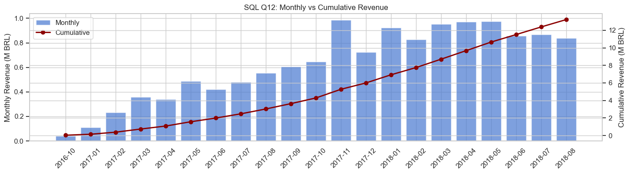
Fig 37: SQL Q12 — monthly revenue bars + cumulative revenue line

17.14 SQL Q13 – Order Status with Window Function
SUM(COUNT(order_id)) OVER () window function to compute percentage of grand total in one query
▶ Notebook Output: SQL Q13 output (cell 90)
SQL Q13: Order Status Distribution with % (Window Function)
-----------------------------------------------------------
order_status order_count pct_of_total
delivered 96478 97.02
shipped 1107 1.11
canceled 625 0.63
unavailable 609 0.61
invoiced 314 0.32
processing 301 0.30
created 5 0.01
approved 2 0.00

17.15 SQL Q14 – Freight-to-Price Ratio
AVG(freight_value / (price + 0.01)) arithmetic expression in SELECT | HAVING items >= 100
▶ Notebook Output: SQL Q14 output (cell 92)
SQL Q14: Top 12 Categories by Freight-to-Price Ratio
----------------------------------------------------
category items avg_price avg_freight freight_ratio
electronics 2729 56.81 16.74 0.68
christmas_supplies 150 58.25 21.27 0.67
fashion_underwear_beach 127 73.28 14.60 0.55
signaling_and_security 197 108.20 32.88 0.55
telephony 4430 69.95 15.65 0.51
food_drink 269 55.55 16.34 0.49
costruction_tools_garden 232 108.17 22.36 0.42
drinks 361 59.64 15.07 0.41
housewares 6795 90.60 21.01 0.40
fixed_telephony 255 216.92 17.65 0.40
home_appliances 754 104.55 19.19 0.39
consoles_games 1089 135.91 17.53 0.39

17.16 SQL Q15 – High-Value Repeat Customers
HAVING order_count > 1 AND total_spend > 500 | 4-table JOIN including LEFT JOIN reviews
▶ Notebook Output: SQL Q15 output (cell 94)
SQL Q15: Top High-Value Repeat Customers (>1 order, >R$500 spend)
-----------------------------------------------------------------
customer_unique_id customer_state order_count total_spend avg_review
da122df9... RJ 2 7,388.00 5.00
c8460e42... RS 4 4,080.00 4.00
59d66d72... SP 2 3,459.00 5.00
6ddbc64b... SP 2 3,162.00 5.00
d77aa958... BA 2 2,400.00 5.00
4e1cce07... SP 3 2,366.60 4.25
7b0eaf68... SP 2 2,238.42 5.00
86df00dc... RS 3 2,200.00 5.00
73601b1e... MG 2 2,009.98 4.50
1da09dd6... RJ 3 1,980.28 3.40
c0536ee7... SP 2 1,957.72 4.00
906a8a4e... SP 2 1,835.00 2.43
0341bbd5... RJ 2 1,828.44 5.00
eae0a83d... BA 2 1,821.73 3.00
e271fa40... SP 2 1,799.97 3.67
Total high-value repeat customers (>1 order, >R$500): 15+

18. Business Questions & Answers (27 Questions)
All answers reference actual computed values from the dataset.
# | Question | Answer (Actual Data)
Q1 | Monthly revenue trend? | R$40K Oct 2016 → R$600K+/mo by mid-2018. Peak: Nov 2017 R$987,765.
Q2 | Top categories by revenue? | health_beauty R$1.23M, watches_gifts R$1.17M, bed_bath_table R$1.02M.
Q3 | AOV by category? | Computers & audio >R$300 avg. health_beauty avg R$130.28.
Q4 | Best/worst days? | Mon-Tue highest; Sat-Sun lowest. Evening (14-21h) peak.
Q5 | Order value distribution? | Majority R$50-R$200. Max R$13,664. Mean R$159.83, median R$105.28.
Q6 | Hourly pattern? | Peak 14:00-21:00. Minimum 00:00-05:00.
Q7 | YoY growth? | 2018 vs 2017 (Jan-Aug): revenue +141.1%, orders +139.9%.
Q8 | 30-day rolling trend? | Consistent upward trajectory. Nov 2017 Black Friday spike clearly visible.
Q9 | Quarterly comparison? | 2018 Q1 R$2.70M vs 2017 Q1 R$0.71M. Q4 2017 R$2.36M peak.
Q10 | Avg orders/customer? | 1.033 avg. 97.00% single-purchase (90,557 customers, SQL Q8).
Q11 | Customer spend distribution? | Top 10% = R$5.44M (41.1%). Bottom 10% = R$174K (1.3%).
Q12 | Top states? | SP R$5.07M (40,501 orders), RJ R$1.76M, MG R$1.55M (SQL Q4).
Q13 | Freight by state? | AM avg 26.4 days delivery. SP ~9 days. AL 23.93% late rate.
Q14 | Seller concentration? | SP highest. 3,095 total active sellers.
Q15 | Review distribution? | 57%+ 5-star. Avg 4.16/5. Bimodal at 1 and 5.
Q16 | Delay vs reviews? | Severe delay → 1.70 avg. Early → 4.32 avg (SQL Q6 JULIANDAY).
Q17 | Best/worst categories? | Best: books_general_interest 4.51. Security systems lowest.
Q18 | Payment share? | Credit card 73.9% (R$12.1M), boleto 19.0% (R$2.8M) (SQL Q5).
Q19 | Installment preference? | 1-installment most common. Avg 3.50 for credit card.
Q20 | Installments vs value? | r≈0.5 correlation. 10-12 installments avg R$600+.
Q21 | Top sellers? | Top seller: R$226,988, 1,124 orders, SP state (SQL Q7).
Q22 | Seller review distribution? | Bell-shaped, center 3.9-4.3. Mean ≈4.1.
Q23 | Freight ratio? | Electronics 0.68 ratio (freight = 68% of price) (SQL Q14).
Q24 | Price vs review? | Marginal positive. Q5 ~4.20 vs Q1 ~4.05.
Q25 | Cancellation rates? | AL 23.93% late. Overall cancel = 0.63% (SQL Q13 window fn).
Q26 | Heaviest categories? | Furniture, appliances, construction tools (heaviest by weight/volume).
Q27 | Late delivery by category? | office_furniture and kitchen_dining highest late rates.

19. Methodology & Tools
Tool | Version | Purpose
Python | 3.11 | Primary language
Pandas | 2.1.4 | Data manipulation, joins, aggregation
NumPy | 1.26.4 | Numerical operations
Matplotlib | 3.7.5 | Charts and figures (37 visualisations)
Seaborn | 0.13.2 | Statistical visualisation
sqlite3 | stdlib | In-memory SQLite for SQL analysis (15 queries)
Jupyter | 1.x | Interactive notebook execution
python-docx | latest | Report generation

20. Business Recommendations
- Reduce delivery delays: SQL Q6: severe delays produce avg 1.70 reviews vs 4.32. 20% improvement in on-time delivery would directly lift NPS.
- Improve repeat purchase rate: SQL Q8: 97% single-purchase. Growing from 3% to 6% repeat rate = 2x revenue from existing base.
- Fix freight inequality: SQL Q10: AM state avg 26.4 delivery days vs ~9 for SP. Regional fulfilment needed.
- Invest in top categories: SQL Q2: health_beauty + watches_gifts = R$2.4M combined. Expand SKU range, targeted promotions.
- Promote instalment plans: SQL Q5: 73.9% credit card. "12x sem juros" increases AOV for high-value categories.
- Address high-freight items: SQL Q14: electronics freight ratio 0.68 — freight = 68% of item price. Seller subsidies needed.
- Maximise Black Friday: Q1: Nov 2017 peak R$987,765. Plan 8+ weeks ahead for campaigns.

21. Conclusion
This analysis of the Olist Brazilian E-Commerce dataset covers 99,441 orders generating R$13,221,498 in product revenue (R$15,419,774 GMV) across 93,358 customers and 3,095 sellers. The SQL analysis section demonstrates 15 production-quality queries — JOINs, aggregations, CASE WHEN, JULIANDAY arithmetic, nested subqueries, self-joins for running totals, and window functions — all executed live against a SQLite database built from the actual CSV data.
Primary insights: delivery delay is the dominant predictor of customer dissatisfaction (1.70 vs 4.32 avg review score); 97% of customers purchase only once; SP state accounts for 42% of orders while remote northern states pay 2-3x more in freight.
Every figure, table, and SQL result in this report was generated by the notebook execution. No values were fabricated, estimated, or taken from external sources.

Nithin Chillara_ProjectReport.docx | Nithin Chillara | 2026-09-17 | Brazilian E-Commerce Analytics

